# Scenario

In each of your assessments for this subject you will place yourself in the following scenario.

You are working in the role of IT Support Officer in the Service Delivery team for the company ITWorks. In your role you are supporting the employees of ITWorks and their clients in assisting them to resolve their ICT service calls to the Service Delivery team and receiving feedback from them on your service.

You will perform the following duties in your role:

* Review and analyse client problems
* Research, plan and implement resolution of client problems
* Analyse asset information for ICT hardware
* Provide one to one instruction if required either verbally or in writing
* Seek, analyse and respond to client feedback for continual improvement purposes

## ITWorks ICT Policies and Procedures

In performing your duties, you will adhere to the following policies and procedures for ITWorks:

* ITWorks Work Instruction – Log ICT Incidents and Service Requests
* ITWorks Work Instruction – Communication Standards
* ITWorks Service Level Agreement
* ITWorks User Documentation Style and Standards Guide

## Quality Assurance Practices

As part of continual service improvement practices at ITWorks you are required to perform mandatory tasks when completing incidents and service requests. Refer to the ITWorks Work Instruction – Log ICT Incidents and Service Request documents for the procedure.

ITWorks Company Background

ITWorks is a company supplying a variety of IT services including:

* Multimedia Services (Video and photographic production, graphic design etc)
* Software Development Services (mobile and web applications)
* Digital Literacy and Microsoft Office Services
* Web site development (online shopping, content management)
* Network Design Services (network and cloud bases solutions, network security)
* ICT Service Management (service desk & field technical support, service design and continuity management)

The company was founded in 2015 and has quickly established its presence in the city of Adelaide, South Australia as a leader in providing high quality services to local and international businesses.

From humble beginnings in a small office located in Payneham with a staff of 3 it wasn’t long before the company expanded into its new larger premises in the heart of the CBD in Pirie St only 2 years after it was established.

Now comprising over 50 staff the future of the business is determined to stay located in South Australia and prides itself on supporting local businesses with their ICT needs.

Over the next 24 months the business plans on expanding its operations in the following areas:

* Virtual reality
* Artificial intelligence
* Big data
* Internet of things
* Blockchain

Refer to the ITWorks Organisation chart on the next page to familiarise yourself with the staff and their roles.

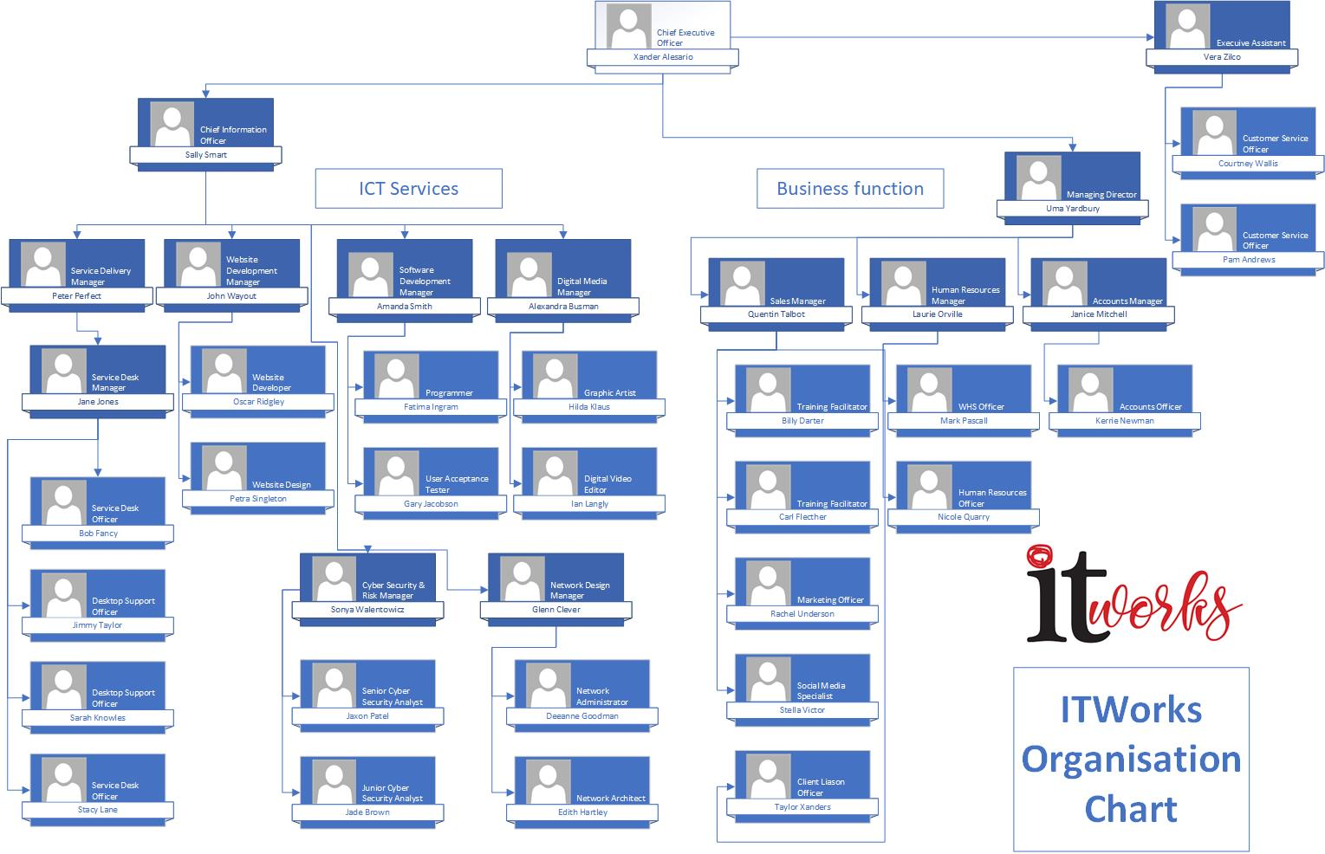

**ITWorks Client Information**

**Albion Bay Council**

The Albion Bay council is located on the eastern coast of Australia and supports a large community living in the surrounding area of the bay. The population was last recorded in June 2021 as 26,548. It’s a popular tourist area that swells in population during the summer months by approximately 3,000 people.

The council provides essential services for the community including the public library. The library offers the community the following services:

* Borrowing items from the library collection
* PC Access
* Resources for local and family history
* Spaces for social and community groups for meetings and workshops

ITWorks provide website hosting and ICT support services to the employees of the council and the public library Monday to Saturday – 9am to 5pm. The public library is also open to the public on Sundays 9am to 12pm during the school holiday periods.

Below is the organisational chart for the public library staff.

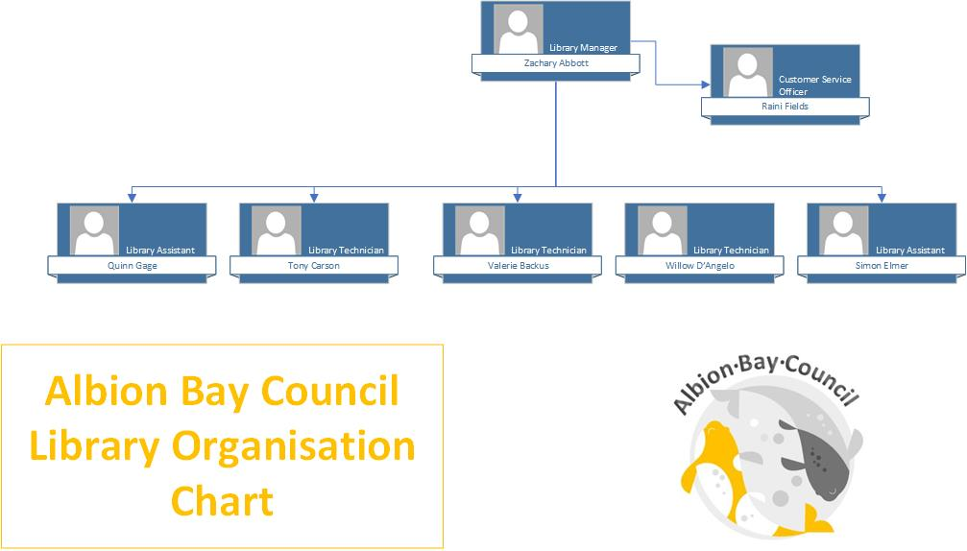

## Client Problems

Virtual machines required for each of these problems can be downloaded from the IT Studies NAS in \Microsoft\VMs\SAS527

**Assessment 1 – Manage ITWorks problem**

Xander Alesario is receiving an error when trying to access the internet with the Firefox web browser on his PC. Vera Zilko has tried resolving the issue but can’t seem to work out what is wrong. Every time she tries to access a website, she is also getting an error. She has closed and re-opened Firefox but the error persists. The error mentions something about being offline.

The problem needs to be resolved as soon as possible as Xander needs to join a Zoom meeting later on that afternoon.

Vera Zilko has called the service desk to report this problem.

**PC Details**

Asset number in iTop: ITW000002

Virtual Machine: ICTSAS527_XanderAlesario

**Assessment 2 – Manage Albion Bay Council library problem**

Quinn Gage has downloaded a video file called Library Cyber Security Month.mp4 from their SharePoint site to the Downloads directory on one of the foyer display PCs. He then tries to copy the file to the D drive where the videos are stored for play back, but then receives an error. The video is to be played on loop during the libraries’ Cyber Security Awareness month in the entrance foyer to promote Cyber Security Awareness. The commencement of Cyber Security Month will be the following Monday.

The PC is also really slow so he’s hoping you can help to resolve this issue as well. There are no other applications running that he can determine.

Quinn Gage has called the service desk to report this problem.

**PC Details**

Asset number in iTop: ITW000001

Virtual Machine: ICTSAS527_Foyer1 PC